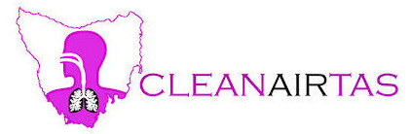
SUBMISSION:

PROTECTION of the ENVIRONMENT OPERATIONS
(CLEAN AIR) REGULATION 2022

Minister for Environment and Heritage
Air.Policy@environment.nsw.gov.au

Thank you for the opportunity to make this submission

Re the the public consultation draft I make reference to:
Part 2 Domestic solid fuel heaters, and
Part 3 Control of burning.

At the outset can I just say that after moving from Tasmania to live in NSW I suffered serious asthma attacks which forced me to return to Tasmania where I currently live.
Whilst I love NSW I am unable to visit whilst harmful air quality continues.
It is that simple.
I support people from NSW making submissions. They require clean air to breathe.
When you can’t breathe nothing else matters.

PART 2 Domestic Solid Fuel Heaters
5 Heaters to which Part applies
(2) However, this Part does not apply to a domestic solid fuel heater if the heater is—
(a) a masonry appliance built on site
This would include a brick fireplace and chimney which is one of the most polluting things smoke-wise in a domestic situation. They are not and cannot even be rated in heat output or efficiency.
They should be banned outright.

(f) an automatic, continuous feed, pellet fuel burning appliance that is designed and manufactured to burn compressed wood or biomass pellets, known as a pellet heater.
“…research has shown that the particles from pellet stoves, although fewer in number than from a log-burning stove, tend to be in the small fine particulate size range that are particularly damaging to health, since they penetrate into the deepest parts of the lungs and can enter the bloodstream.” https://woodsmokepollution.org/pellet-stoves.html#:~:text=Other%20research%20has%20shown%20that,and%20can%20enter%20the%20bloodstream.
Further real-time studies must be undertaken and Standards set to show pellet heaters cannot be polluting appliances that harm people’s health.

(b), (c), (d) & (e)
Likewise, it is too simple to exempt these appliances if they are emitters of wood smoke particulates. There are alternatives and these appliances should either be removed from service or made to run on cleaner forms of energy.

This is most important when:
"Outdoor air pollution is a leading environmental cause of cancer deaths." - IARC 17/10/2013.
The specialized cancer agency of the World Health Organization, for Research, announced today that it has classified outdoor air pollution as
carcinogenic to humans (Group 1).
After thoroughly reviewing the latest available scientific literature, world leading experts convened by the IARC Monographs Programme concluded that there is sufficient evidence that exposure to outdoor air pollution causes lung cancer (Group 1).
They also noted a positive association with an increased risk of bladder cancer.
Particulate matter, a major component of outdoor air pollution, was evaluated separately and was also classified as carcinogenic to humans (Group 1).
NOTE: Similar Group 1 carcinogens are asbestos, arsenic, formaldehyde, and mustard gas
We must stop burning stuff.

6 Sale of heaters—certificates of compliance
(1) A person must not sell a model of a domestic solid fuel heater to another person
unless—
(a) the heater is marked in accordance with Standard 4012 and Standard 4013, and
(b) a certificate (a certificate of compliance) is in force in relation to the model
that certifies the model—
(i) complies with Standard 4012 and Standard 4013, and
(ii) has an overall average efficiency of not less than 60% as tested and
calculated in accordance with Standard 4012, and
(iii) has an appliance particulate emission factor, as tested and calculated in
accordance with Standard 4013, not greater than—
(A) for heaters with catalytic combustors—0.8 grams per kilogram,
Or
(B) otherwise—1.5 grams per kilogram, and
(c) if the sale is to a person whose business includes the wholesale or retail sale of
domestic solid fuel heaters—a copy of the certificate of compliance has been
given to the purchaser.
These Standards have been shown to do very little to stop smoke emissions.
They do nothing to mandate the phase out of older non-complying wood heaters.
They do nothing to stop people inhaling wood smoke in their own homes with smoke-spill when the heater door is opened.
They do nothing to ensure the heater does not emit smoke within the home: https://cleanairtas.com/departments/wood-heater-installation.docx
They do nothing to ensure the heaters are operated by owners in the way they were certified under scientific conditions, i.e. real-life conditions are very different:
The current Australian Standard does not measure real-life emissions. Research shows that real-life emissions of new wood heaters are little different from older models and have estimated health costs of thousands of dollars per heater per year - http://woodsmoke.3sc.net/files/Health_Costs_Allowing_New_Wood_Heaters.pdf

Pollution from wood heaters is the MAJOR source of hazardous pollution in NSW, accounting for 46% of population-weighted exposure to PM2.5 pollution in Sydney, at least 100 premature deaths every year, and health costs of thousands of dollars per wood heater per year.
And, local outlets are selling 20Kg bags of firewood for approximately $20 a bag. That is $1000 per tonne and a home can burn many tonnes per year. High wood prices are forcing people to burn prohibited fuels.

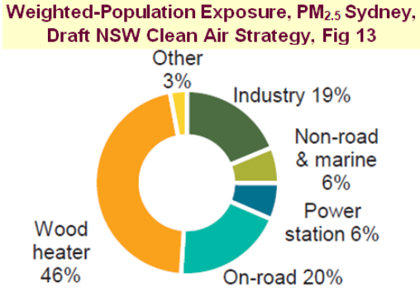

Asthma Australia reported that NSW residents whose health is being damaged by other people’s wood heater pollution are largely unable to protect themselves - https://asthma.org.au/about-us/media/public-would-support-a-phase-out-of-woodfire-heaters/

The POEO therefore needs major revisions to include practical and effective provisions to assist residents who are currently suffering damage to their health or lifestyle because of other people’s wood smoke. Councils should be advised that video evidence (which is entirely consistent with the current POEO act) is acceptable evidence of excessive smoke. Other evidence, including validated PM2.5 measurements from community monitoring should also be considered acceptable. Laser particle counters are now considered acceptable by authorities to measure particle pollution when cross-calibrated against reference monitors. This same process should be made available to community groups. This would aid in cost savings to locate point sources of smoke, to prevent hospital admissions and doctor’s visits and to prevent sufferers having to use life-long medications. Shortened life-spans and suffering must be factored in.
The Centre for Air pollution, energy and health Research (CAR, an NHMRC Centre of Research Excellence) states in a position paper by 11 experts (published August 2021) that "Current Australian wood heater standards are insufficient to protect health" - see https://www.car-cre.org.au/_files/ugd/d8be6e_a27f05a82f8c47378ffa9dcbacb6cc04.pdf

The POEO needs a major upgrade informed by a benefit cost analysis evaluating whether new wood heaters with estimated health costs of thousands of dollars per heater per year should be permitted on residential blocks smaller than 2 hectares that have electricity grid connections. In the interim, local councils need improved guidance and legislation to manage the installation of new wood heaters, including requirements to consult neighbours whose health might be impacted by the pollution.

Better Regulation Principle 3 (RIS, page 53) requires the impact of government action to be properly understood by considering the costs and benefits of a range of options. Given the estimated health costs of installing new wood heaters of thousands of dollars per heater per year, the POEO needs to consider a range of options (e.g. developing a new standard that reflects real-life emissions and limiting installations in areas where the health costs exceed the benefits and there are affordable alternatives with lower running costs than buying firewood).

Further consultation on the POEO is required because many people who have expressed concerns about the failure of local councils to protect their health from other people's wood smoke would not be aware of the need to upgrade the POEO to provide practical and effective provisions to solve these problems.

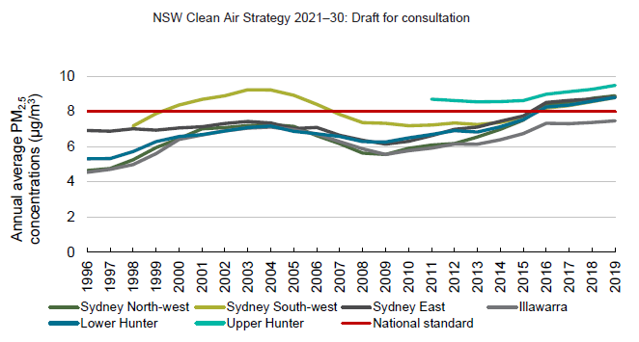
Air pollution is getting worse –
The proposed strategy will not ‘flatten the curve’ and protect our health

"Every single disease that is non-communicable is impacted by air pollution.
It is not only involved in worsening diseases but in causing them, and new diseases that would not otherwise occur are happening because of air pollution."-
Sir Stephen Holgate, National Clean Air Conference Nov. 20/21

If all these conditions are not met we are not protecting the environment and the Regulation name must be changed
In any case the name of the Regulation should be simplified to the:
‘NSW Clean Air Regulations – 2022’

Part 3 Control of burning
Division 2 Obligation to prevent air pollution:
The obligation to prevent air pollution must apply to all sections in this Regulation.
Burning should be a last resort. For example, there are smokeless ways for fuel reduction, and backyard burning should not occur unless there is no other way to dispose of green waste.
Download Prof Davis Bowman, fire ecologist, “Who cares whether we achieve fuel management with burning, fuel management can be achieved with brush cutters, fuel management can be achieved with goats”:
https://cleanairtas.com/departments/ABC-The_Drum.David-Bowman13.11.19.wmv

To prevent air pollution we must stop burning stuff.
The World Health Organisation says with regards to particle pollution there is no minimum level at which harm will occur.

Clive M Stott
http://www.cleanairtas.com
3nd June 2022

